**15. Detects double and triple spaces in a string.**

**Exercise**

* **Write a  program to detect the index of double and triple spaces in a string given by the user.**

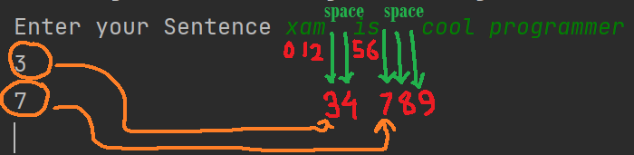

**Approach:**

**So here we did like this**

**Java: The indexOf() method returns the position of the first occurrence of specified character(s) in a string**

**Python : The .index() method return the position of first occurrence of specified character(s) in a string**

**Solution 👇**

**Java :**

**import java.util.*;**

**public class code_xam {**

**public static void main(String[] args) {**

**Scanner sc = new Scanner(System.in);**

**System.out.print("Enter your Sentence ");**

**String str1 = sc.nextLine();**

**System.out.println(str1.indexOf("  "));**

**System.out.println(str1.indexOf("   "));**

**}**

**}**

**output:**

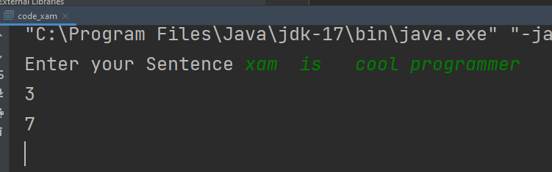

**Python :**

**txt = input("Enter Your sentence with 2 and 3 spaces:\n")**

**print(txt.index("  "))**

**print(txt.index("   "))**

**output:**

